**IFS Spiral**

Written by [Paul Bourke](http://local.wasp.uwa.edu.au/%7Epbourke/fractals/)  
January 2002

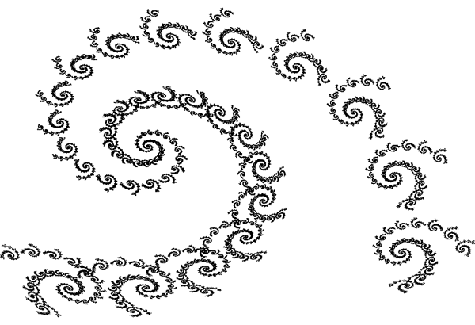

The IFS equations are as follows

xn+1 = a xn + b yn + e

yn+1 = c xn + d yn + f

The parameter table:

set 1 set 2 set 3

a 0.787879 -0.121212 0.181818

b -0.424242 0.257576 -0.136364

c 0.242424 0.151515 0.090909

d 0.859848 0.053030 0.181818

e 1.758647 -6.721654 6.086107

f 1.408065 1.377236 1.568035

probability 0.90 0.05 0.05

**IFS Mandelbrot-like**

Written by [Paul Bourke](http://local.wasp.uwa.edu.au/%7Epbourke/fractals/)  
february 1999

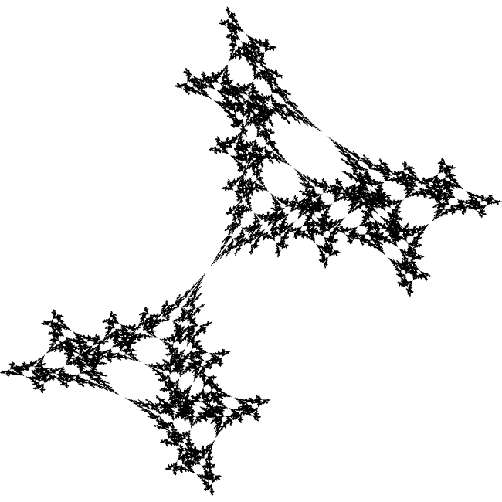

The IFS equations are as follows

xn+1 = a xn + b yn + e

yn+1 = c xn + d yn + f

The parameter table:

set 1 set 2

a 0.2020 0.1380

b -0.8050 0.6650

c -0.6890 -0.5020

d -0.3420 -0.2220

e -0.3730 0.6600

f -0.6530 -0.2770

**IFS Tree**

Written by [Paul Bourke](http://local.wasp.uwa.edu.au/%7Epbourke/fractals/)  
January 1999

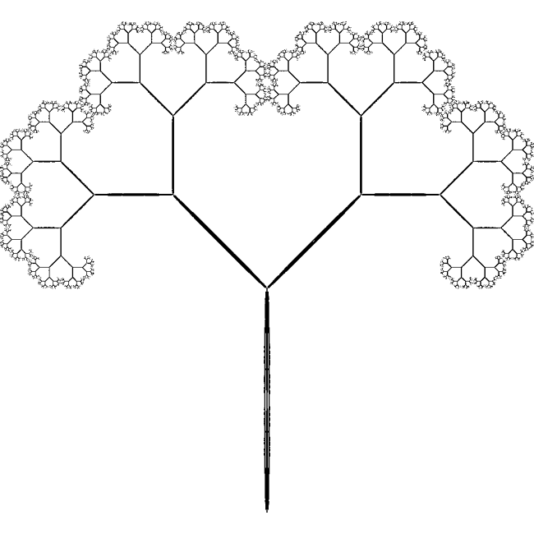

The IFS equations are as follows

xn+1 = a xn + b yn + e

yn+1 = c xn + d yn + f

The parameter table:

set 1 set 2 set 3 set 4

a 0.0100 -0.0100 0.4200 0.4200

b 0.0000 0.0000 -0.4200 0.4200

c 0.0000 0.0000 0.4200 -0.4200

d 0.4500 -0.4500 0.4200 0.4200

e 0.0000 0.0000 0.0000 0.0000

f 0.0000 0.4000 0.4000 0.4000

**IFS Tree**

Written by [Paul Bourke](http://local.wasp.uwa.edu.au/%7Epbourke/fractals/)  
January 1999

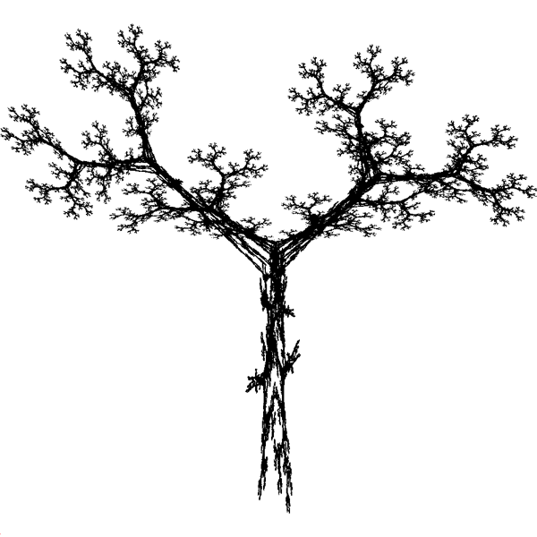

The IFS equations are as follows

xn+1 = a xn + b yn + e

yn+1 = c xn + d yn + f

The parameter table:

set 1 set 2 set 3 set 4 set 5

a 0.1950 0.4620 -0.6370 -0.0350 -0.0580

b -0.4880 0.4140 0.0000 0.0700 -0.0700

c 0.3440 -0.2520 0.0000 -0.4690 0.4530

d 0.4430 0.3610 0.5010 0.0220 -0.1110

e 0.4431 0.2511 0.8562 0.4884 0.5976

f 0.2452 0.5692 0.2512 0.5069 0.0969

probability 0.2 0.2 0.2 0.2 0.2

**Leaf IFS**

Written by [Paul Bourke](http://local.wasp.uwa.edu.au/%7Epbourke/fractals/)  
January 2002

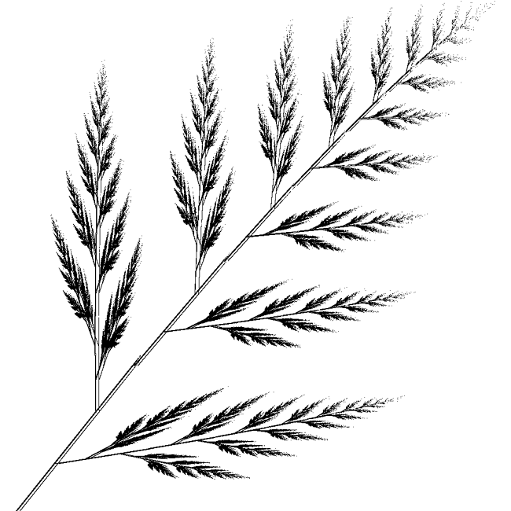

The IFS equations are as follows

xn+1 = a xn + b yn + e

yn+1 = c xn + d yn + f

The parameter table:

set 1 set 2 set 3 set 4

a 0.0000 0.7248 0.1583 0.3386

b 0.2439 0.0337 -0.1297 0.3694

c 0.0000 -0.0253 0.3550 0.2227

d 0.3053 0.7426 0.3676 -0.0756

e 0.0000 0.2060 0.1383 0.0679

f 0.0000 0.2538 0.1750 0.0826

**Sand dollar snowflake IFS**

Written by [Paul Bourke](http://local.wasp.uwa.edu.au/%7Epbourke/fractals/)  
January 2002

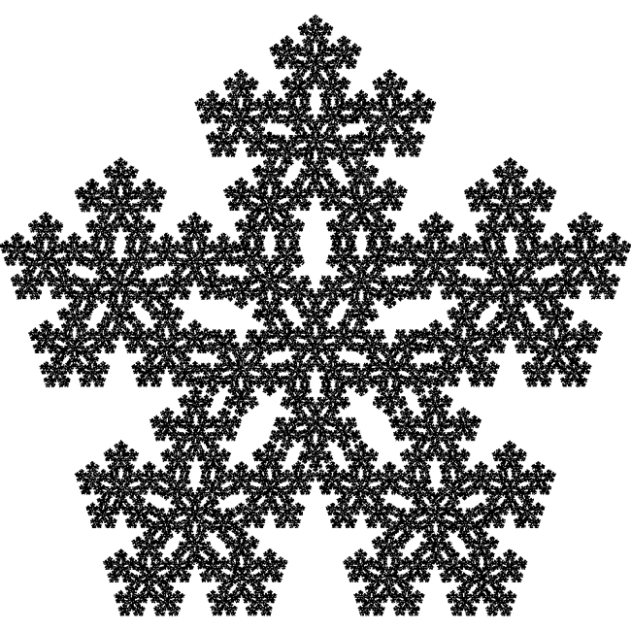

The IFS equations are as follows

xn+1 = a xn + b yn + e

yn+1 = c xn + d yn + f

The parameter table:

set 1 set 2 set 3 set 4 set 5 set 6

a 0.38200 0.11800 0.11800 -0.30900 -0.30900 0.38200

b 0.00000 -0.36330 0.36330 -0.22450 0.22450 0.00000

c 0.00000 0.36330 -0.36330 0.22450 -0.22450 0.00000

d 0.38200 0.11800 0.11800 -0.30900 -0.30900 -0.38200

e 0.30900 0.36330 0.51870 0.60700 0.70160 0.30900

f 0.57000 0.33060 0.69400 0.30900 0.53350 0.67700

**IFS Tree**

Written by [Paul Bourke](http://local.wasp.uwa.edu.au/%7Epbourke/fractals/)  
January 1999

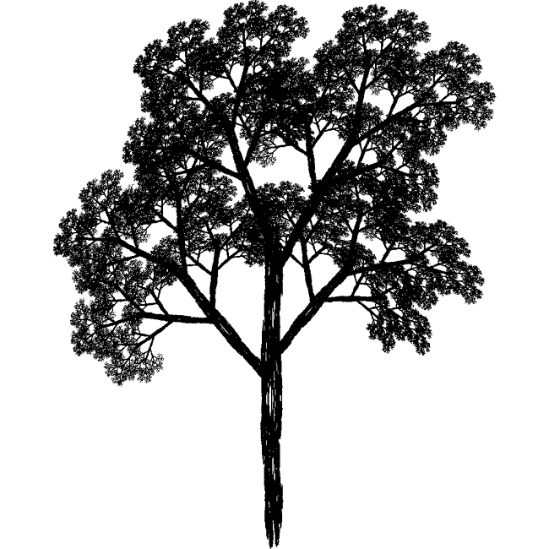

The IFS equations are as follows

xn+1 = r cos(theta) xn - s sin(phi) yn + e

yn+1 = r sin(theta) xn + s cos(phi) yn + f

The parameter table:

set 1 set 2 set 3 set 4 set 5 set 6

r 0.0500 0.0500 0.6000 0.5000 0.5000 0.5500

s 0.6000 -0.5000 0.5000 0.4500 0.5500 0.4000

theta 0.0000 0.0000 0.6980 0.3490 -0.5240 -0.6980

phi 0.0000 0.0000 0.6980 0.3492 -0.5240 -0.6980

e 0.0000 0.0000 0.0000 0.0000 0.0000 0.0000

f 0.0000 1.0000 0.6000 1.1000 1.0000 0.7000

**IFS Tree**

Written by [Paul Bourke](http://local.wasp.uwa.edu.au/%7Epbourke/fractals/)  
January 1999

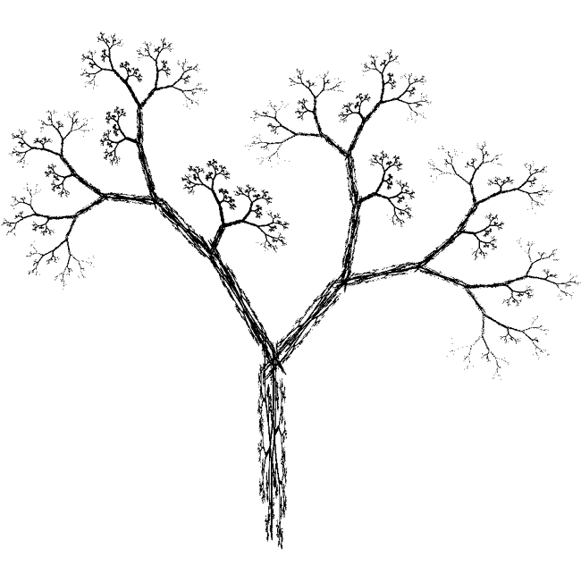

The IFS equations are as follows

xn+1 = a xn + b yn + e

yn+1 = c xn + d yn + f

The parameter table:

set 1 set 2 set 3 set 4 set 5 set 6 set 7

a 0.0500 -0.0500 0.0300 -0.0300 0.5600 0.1900 -0.3300

b 0.0000 0.0000 -0.1400 0.1400 0.4400 0.0700 -0.3400

c 0.0000 0.0000 0.0000 0.0000 -0.3700 -0.1000 -0.3300

d 0.4000 -0.4000 0.2600 -0.2600 0.5100 0.1500 0.3400

e -0.0600 -0.0600 -0.1600 -0.1600 0.3000 -0.2000 -0.5400

f -0.4700 -0.4700 -0.0100 -0.0100 0.1500 0.2800 0.3900

**IFS fern**

Written by [Paul Bourke](http://local.wasp.uwa.edu.au/%7Epbourke/fractals/)  
January 1999

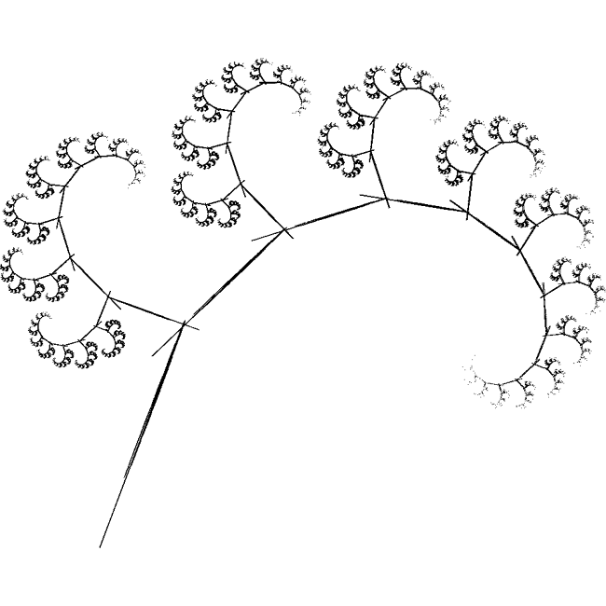

The IFS equations are as follows

xn+1 = a xn + b yn + e

yn+1 = c xn + d yn + f

The parameter table:

set 1 set 2 set 3

a 0.0100 0.7000 0.0000

b -0.4100 0.3300 0.1750

c 0.3900 -0.3500 0.0130

d 0.0000 0.7000 0.4600

e -0.2800 0.1850 -0.0950

f -0.1850 0.0150 -0.2850

# How to create the IFS Fern

Written by [Paul Bourke](http://local.wasp.uwa.edu.au/%7Epbourke/fractals/)  
January 1988

See also  
[Version by Jay Link](http://local.wasp.uwa.edu.au/%7Epbourke/fractals/ifs_fern_a/svgalib.c) designed for [SVGALIB](http://www.svgalib.org/)  
and [Object pascal](http://local.wasp.uwa.edu.au/%7Epbourke/fractals/ifs_fern_a/omar_awile.html) version by Omar Awile.

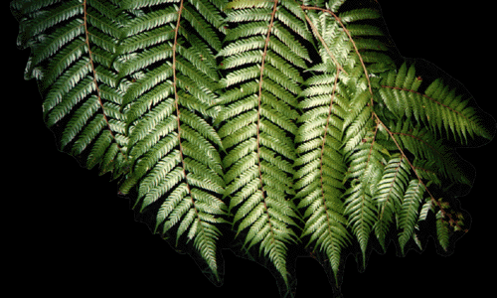

|  |  |
| --- | --- |
| One of the very common and attractive forms generated by Iterated Function Systems (IFS) is the fern leaf shown on the right. The following will describe how to generate this form and allow the reader to experiment with other IFS generators.  Iterated function systems are described by repeatedly computing terms in two series, one series describes the x coordinate and the other series the y coordinate. The equations describe translation, scaling, rotation, and shearing of points in a plane with the restriction that the transformations are "affine".  The general form of the series are as follows  xn+1 = a xn + b yn + e  yn+1 = c xn + d yn + f  A point is drawn at each pair (xi,yi) for i greater than some number, typically 10 to 100.  The magic is in finding the values of (a,b,c,d,e,f) that give the desired form. In many application it is necessary to have a number of sets of (a,b,c,d,e,f). As the series is being generated a particular set is chosen at random for each term. Such IFS systems are often known as Random Iterated Function Systems. | IFS Fern |

|  |  |  |  |  |  |  |  |  |  |  |  |  |  |  |  |  |  |  |  |  |  |  |  |  |  |  |  |  |  |  |  |  |  |  |  |  |  |  |  |  |  |  |  |  |  |  |
| --- | --- | --- | --- | --- | --- | --- | --- | --- | --- | --- | --- | --- | --- | --- | --- | --- | --- | --- | --- | --- | --- | --- | --- | --- | --- | --- | --- | --- | --- | --- | --- | --- | --- | --- | --- | --- | --- | --- | --- | --- | --- | --- | --- | --- | --- | --- |
| The fern can be constructed using the table of value on the right.  It turns out that if the different sets of (a,b,c,d,e,f) are chosen with appropriate probabilities then the fern will "emerge" much faster and evenly than if the sets are chosen with equal chance. The last row in the table gives the optimal probabilities.  The fern above resulted from 100 thousand (105) iterations, that is, 100 thousand points are drawn (of course when drawn on the bitmap many will overlap) | |  |  |  |  |  | | --- | --- | --- | --- | --- | | - | set1 | set2 | set3 | set4 | | a | 0.0 | 0.2 | -0.15 | 0.75 | | b | 0.0 | -0.26 | 0.28 | 0.04 | | c | 0.0 | 0.23 | 0.26 | -0.04 | | d | 0.16 | 0.22 | 0.24 | 0.85 | | e | 0.0 | 0.0 | 0.0 | 0.0 | | f | 0.0 | 1.6 | 0.44 | 1.6 | | p | 0.1 | 0.08 | 0.08 | 0.74 | |  |  |  |  |  | |

The image is self similar at all scales, one can zoom in as far as one wishes and the fronds will continue to resolve themselves. For example, the following image is a zoom in by 50. Note however that it takes an ever increasing number of iterations to resolve the image as the zoom factor increases, this image took 100 million (108) iterations.

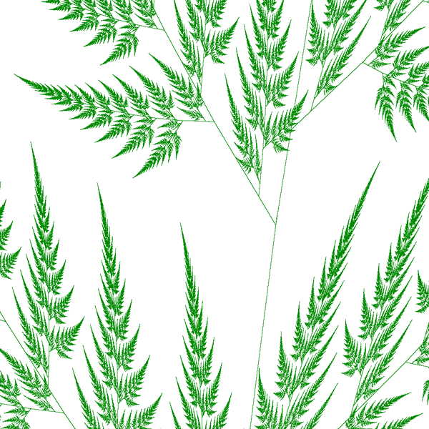

Some straightforward C source is given here [(source.c)](http://local.wasp.uwa.edu.au/%7Epbourke/fractals/ifs_fern_a/source.c) which generates the figure shown above. Note, you will have to supply your own image drawing tools.

|  |  |
| --- | --- |
| A slightly different set of codes gives the result on the right.  set 1 set 2 set 3 set 4  a 0.0 0.2 -0.15 0.85  b 0.0 -0.26 0.28 0.04  c 0.0 0.23 0.26 -0.04  d 0.16 0.22 0.24 0.85  e 0.0 0.0 0.0 0.0  f 0.0 1.6 0.44 1.6  probability 0.01 0.07 0.07 0.85 | http://local.wasp.uwa.edu.au/%7Epbourke/fractals/ifs_fern_a/second.gif |

**Angular fern by Roger Bagula**

[Basic source code](http://local.wasp.uwa.edu.au/%7Epbourke/fractals/ifs_fern_a/roger11.basic) -- [C source code](http://local.wasp.uwa.edu.au/%7Epbourke/fractals/ifs_fern_a/roger11.c)

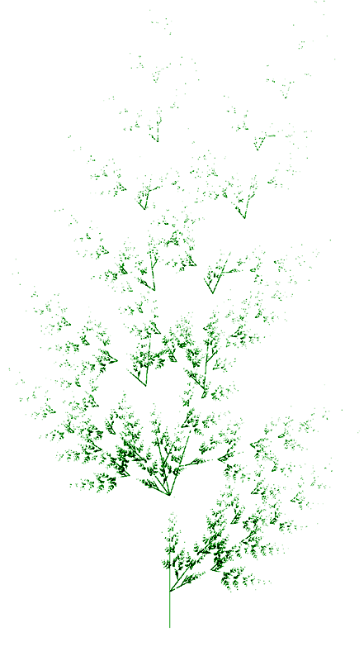

### References

**Demko, S., Hodges, L., and Naylor B**  
Construction of Fractal Objects with Iterated Function Systems  
Computer Graphics 19, 3, July 1985, Pages 271-278

**Barnsley, M.**  
Fractals Everywhere  
Academic press, 1988

**Barnsley, F., and Sloan, A.D.**  
A Better Way to Compress Images  
Byte Magazine, January 1988, Pages 215-222

**Oppenheimer, P.E.**  
Real Time Design and Animation of Fractal Plants and Trees  
Computer Graphics, 20, 4, 1986

**Reghbati, H.K.**  
An Overview of Data Compression Techniques  
Computer, 14, 4, 1981, Pages 71-76

**IFS Dragon**

Written by [Paul Bourke](http://local.wasp.uwa.edu.au/%7Epbourke/fractals/)  
January 2002

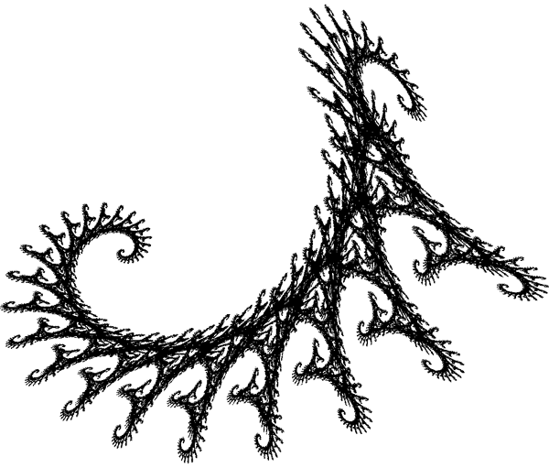

The IFS equations are as follows

xn+1 = a xn + b yn + e

yn+1 = c xn + d yn + f

The parameter table:

set 1 set 2

a 0.824074 0.088272

b 0.281428 0.520988

c -0.212346 -0.463889

d 0.864198 -0.377778

e -1.882290 0.785360

f -0.110607 8.095795

probability 0.8 0.2

**IFS Twig**

Written by [Paul Bourke](http://local.wasp.uwa.edu.au/%7Epbourke/fractals/)  
January 2002

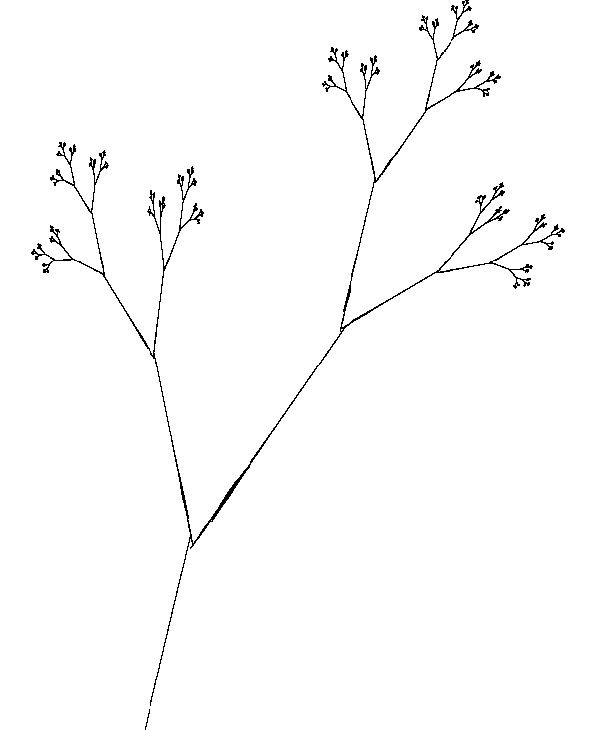

The IFS equations are as follows

xn+1 = a xn + b yn + e

yn+1 = c xn + d yn + f

The parameter table:

set 1 set 2 set 3

a 0.387 0.441 -0.468

b 0.430 -0.091 0.020

c 0.430 -0.009 -0.113

d -0.387 -0.322 0.015

e 0.2560 0.4219 0.4

f 0.5220 0.5059 0.4

probability 1/3 1/3 1/3

**Christmas tree IFS**

Written by [Paul Bourke](http://local.wasp.uwa.edu.au/%7Epbourke/fractals/)  
January 2002

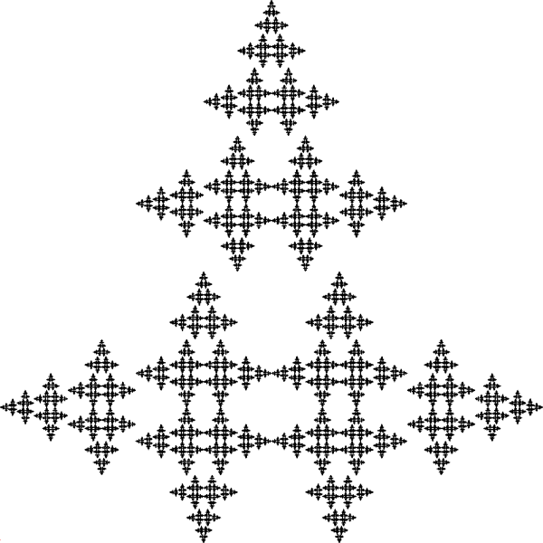

The IFS equations are as follows

xn+1 = a xn + b yn + e

yn+1 = c xn + d yn + f

The parameter table:

set 1 set 2 set 3

a 0.0 0.0 0.5

b -0.5 0.5 0.0

c 0.5 -0.5 0.0

d 0.0 0.0 0.5

e 0.5 0.5 0.25

f 0.0 0.5 0.5

probability 1/3 1/3 1/3

**Construction of IFS Fractals of Specific Similarity Dimension**

By Roger Bagula  
Compiled and graphics by [Paul Bourke](http://local.wasp.uwa.edu.au/%7Epbourke/fractals/)  
26 July 1998

[Basic source code](http://local.wasp.uwa.edu.au/%7Epbourke/fractals/ifs_curved/roager5.basic) -- [C source code](http://local.wasp.uwa.edu.au/%7Epbourke/fractals/ifs_curved/roger5.c)

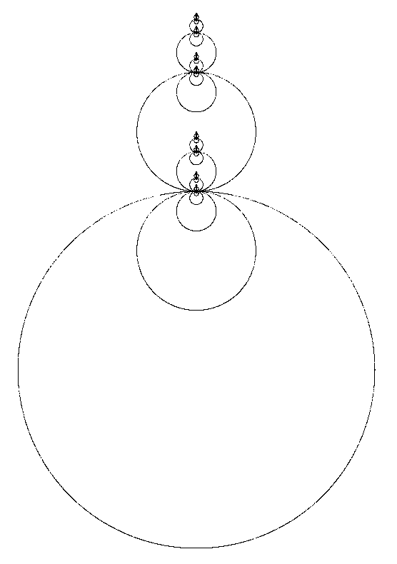

|  |
| --- |
| For some fractal sets we agree on their dimension: the Cantor set , the von Koch 3 set and the Sierpinski gasket. We also agree that close plane curves have dimension of one. What if we combine one set with another? The union of the two sets will behave as if it had a dimension of the combination set.  On page 160 of Edgar's fractal geometry he defines a Cantor dust as:  1) z = z / 3  2) z = z / 3 + 2/3  Such a set has similarity dimension by Moran's formula of:  3) sc = log(2) / log(3)  It is a Fatou type of set in being unconnected and of dimension less than one. In my work with circle measures I discovered a way to get closed curves:  4) r = m(x,y)  for some measure function m(x,y) and:  5) z = z / r + c(i)  Such closed connected curves have dimension of one exactly. Combination of the Cantor dust and this measure gives an IFS set union with dimension:  6) s = 1 + sc = Hd(curve) + Hd(Cantor dust)  and equations:  7) z = z / m(x,y) + c1 ; p = 1/2  8) z = z / 3 ; p = 1/4  9) z = z / 3 + 2/3 ; p = 1/4  For a circle I use:  10) m(x,y) = sqr(x^2 + y^2)  and c1=-1. I actually have to add a random parity from the set {1,-1} to get both sides of the circle to plot, but the resulting IFS works well. Now, topologically speaking all closed smooth plane curves are dimensionally alike. I had figured out how to make measures that give a lot of different such curves! The regular polygons as inner and outer measures in Hausdorff Space were my best success. The triangle measure is:  11) w = angle(x,y)  12) m(x,y) = Max(Max(-cos(w + 2 * pi / 3), -cos(w + 4 * pi / 3)), -cos(w + 6 * Pi / 3))  This measure gives equilateral triangles instead of circles. Several other measures also work well in these equations. I got a Cantor-Sierpinski by arrangement of the constants. All of these sets share the same dimensionality in theory:  13) set =(Cantor dust set) Union ( curve point set)  14) Hd(set) = Hd(curve) + Hd(Cantor dust)  It works so well I don't have the heart to be too critical, but after seeing the actual sets and changing their shapes at will, I have to say that I doubt that 14) is generally true (specially when I use an hyperbolic measure, for instance). This morning I experimented with the middle fifth Cantor dust set:  15) z = z / 5  16) z = z / 5 + 2/5  17) z = z / 5 + 4/5  And got it to work with a number of curves as well, but used equal probability for the four transforms. The result is not a connected set in the triangular case, but still is in the circle case, even if the circles take a long time to form. I also experimented with replacement of transforms in the Sierpinski sets with alternate triangles to get some pretty fractals. That raised the question of what the dimensionality of connected sets with more than one curve might be: regular transform dimension comes from the Moran equation, but the curves are puzzling:  18) 1 = ((n - int(n / 2)) / 2)^s + (int(n / 2) / m(x,y))^s  Since I have been using :  19) m(x,y) <= 1  We can get an estimate by using the maximum as one and even n:  20) 1 = (n / 2)^s * (1 / 2^s + 1)  If s maxes at two an upper limit is:  21) s = log(5) / (log(2) - log(n / 2))  Which isn't a very good formula for n = 4! Set theory seems to work well until you get to these mixed curves and self-similar sets. I have yet to do some experimentation with this concept, but these Designer fractals a definite step toward making fractals in any desired shape at demand without using a Barnsley type of reduction. |

~

**IFS Chaos Text**

Written by [Paul Bourke](http://local.wasp.uwa.edu.au/%7Epbourke/fractals/)  
January 2002

Contributed by Earl Glynn (Original source unknown)

The following is a rather unusual example of an iterated function system (IFS) that involves choosing at random one of 19 transformations of the form

xn+1 = a xn + b yn + e  
yn+1 = c xn + d yn + f

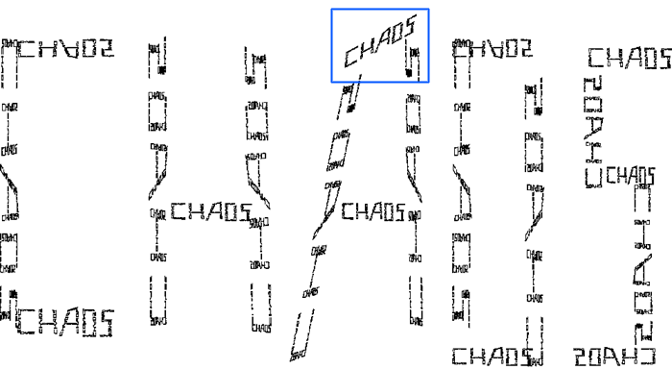

A zoom into the top portion of the "A", shown in blue above, shows that it is indeed made up of smaller versions of the word "chaos".

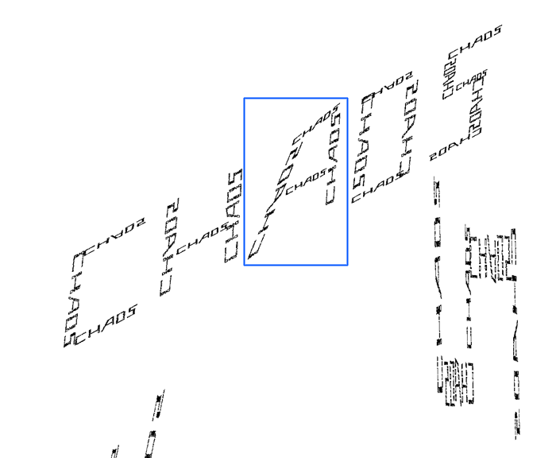

And to labour the point, the following is a further zoom into the "A", shown in blue above.

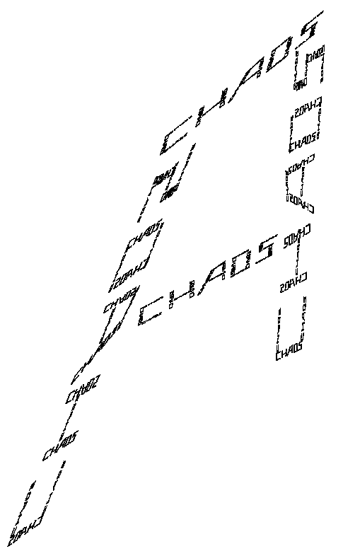

The parameter table:

a b c d e f

0 0.053 -0.429 0 -7.083 5.43

0.143 0 0 -0.053 -5.619 8.513

0.143 0 0 0.083 -5.619 2.057

0 0.053 0.429 0 -3.952 5.43

0.119 0 0 0.053 -2.555 4.536

-0.0123806 -0.0649723 0.423819 0.00189797 -1.226 5.235

0.0852291 0.0506328 0.420449 0.0156626 -0.421 4.569

0.104432 0.00529117 0.0570516 0.0527352 0.976 8.113

-0.00814186 -0.0417935 0.423922 0.00415972 1.934 5.37

0.093 0 0 0.053 0.861 4.536

0 0.053 -0.429 0 2.447 5.43

0.119 0 0 -0.053 3.363 8.513

0.119 0 0 0.053 3.363 1.487

0 0.053 0.429 0 3.972 4.569

0.123998 -0.00183957 0.000691208 0.0629731 6.275 7.716

0 0.053 0.167 0 5.215 6.483

0.071 0 0 0.053 6.279 5.298

0 -0.053 -0.238 0 6.805 3.714

-0.121 0 0 0.053 5.941 1.487

**Maple Leaf IFS**

Written by [Paul Bourke](http://local.wasp.uwa.edu.au/%7Epbourke/fractals/)  
January 2002

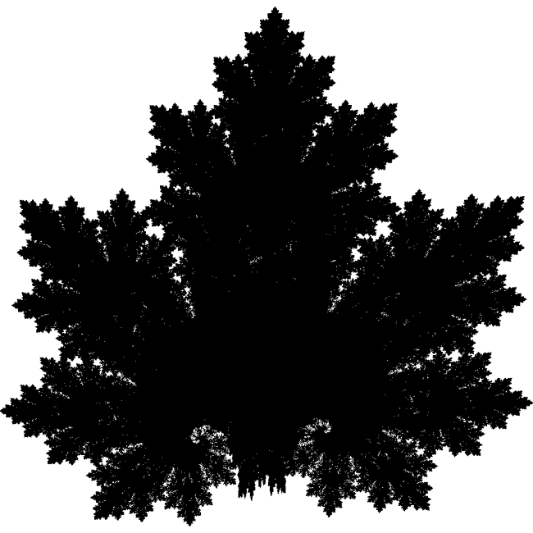

The IFS equations are as follows

xn+1 = a xn + b yn + e

yn+1 = c xn + d yn + f

The parameter table:

set 1 set 2 set 3 set 4

a 0.1400 0.4300 0.4500 0.4900

b 0.0100 0.5200 -0.4900 0.0000

c 0.0000 -0.4500 0.4700 0.0000

d 0.5100 0.5000 0.4700 0.5100

e -0.0800 1.4900 -1.6200 0.0200

f -1.3100 -0.7500 -0.7400 1.6200

|  |  |
| --- | --- |
| Gingerbread man Written by [Paul Bourke](http://local.wasp.uwa.edu.au/%7Epbourke/fractals/) January 1991 | xn+1 = 1 - yn + | xn | yn+1 = xn |

